DAA LAB ACTIVITY – 2
Name: RATHISH P P
Roll no: CH.SC.U4CSE24238

Bubble sort
Code:
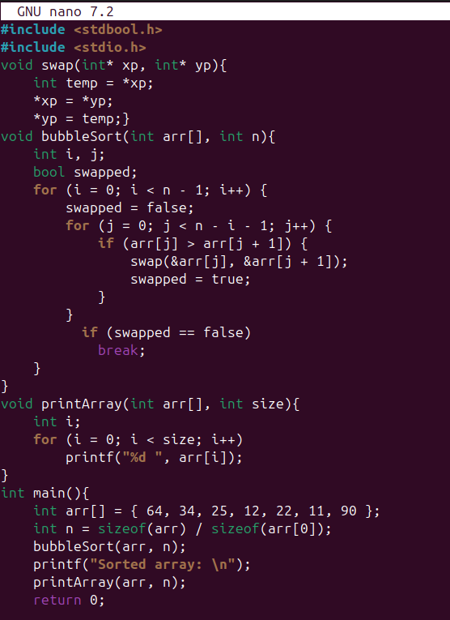
Output:
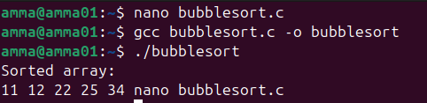
Inference:
Here I have used pointers to sort the elements. The sorting process takes place in single iteration.

Insertion sort:
Code:
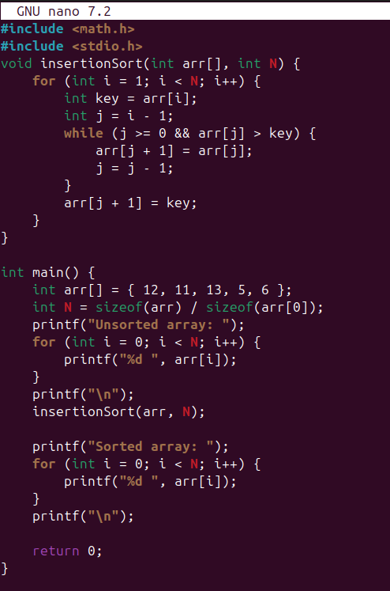
Output :
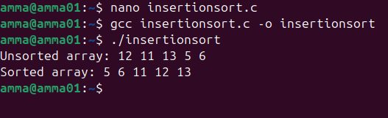
Inference:
In this insertion sort the sorting process takes a lot of iterations which makes it take more time to sort the list of lengthy elements.

Selection sort
Code:
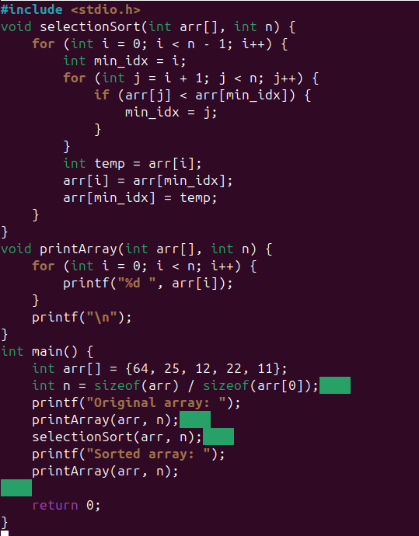
Output :
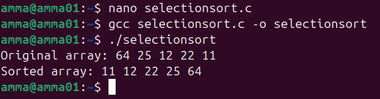
Inference:
In the selection sort the sorting takes place in single iteration where two loops are used.

Bucket sort

Code:
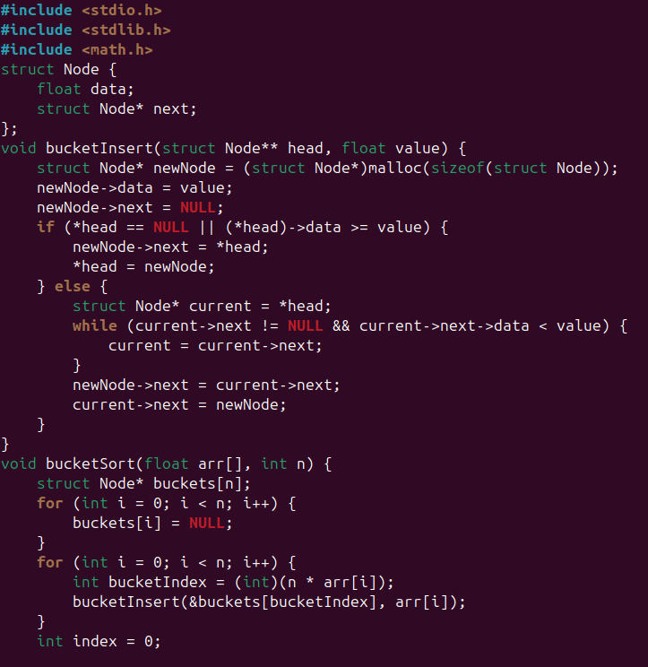
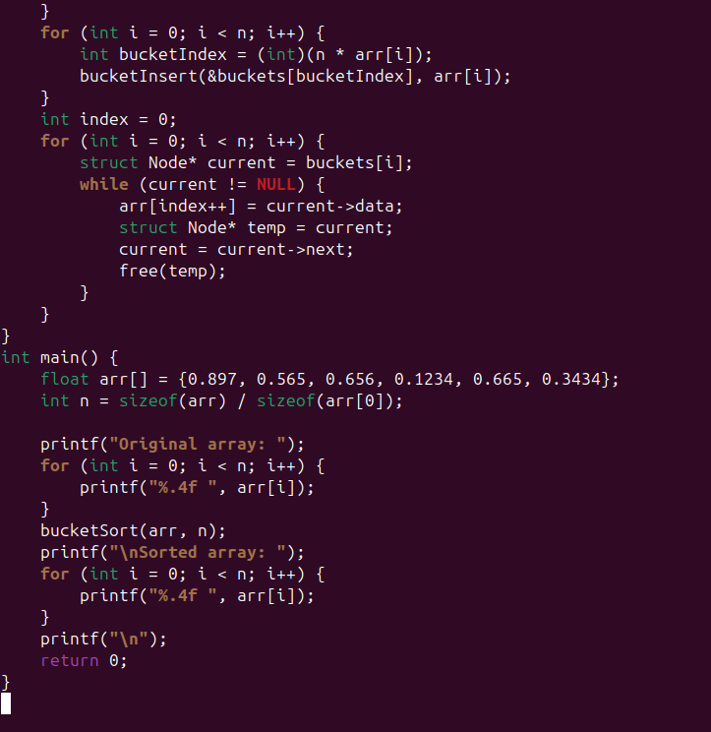

Output:
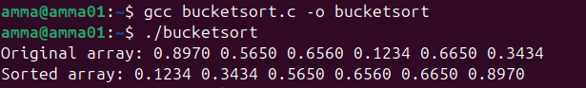
Inference:
In this sorting technique the elements are divided into buckets and sorted until the correct sorted elements are identified.

Heap sort

Code:
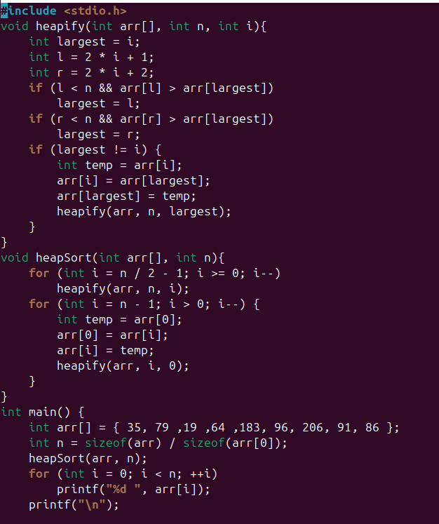
Output:
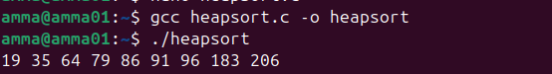
Inference:
In this sorting method the elements are sorted using binary tree which is more efficient but it takes a lot of time to get sorted.

